**Task 3.1P – Answers**

**Question 1**

One can make use of webhooks to publish data to a third-party website or service. There are various types of webhooks that particle devices can use including POST, GET and PUT. A POST webhook is used for sending data (i.e.: a sensor reading) to the website of choice while a GET webhook is used to receive data. A use case of this would be to receive information in response to some data that was sent by the device.

**Question 2**

1. Set up your particle device and connect the sensor you wish to take readings from.
2. Write a basic program in the Particle IDE that reads the sensor data. Verify the code and make sure it is running on your device.
3. Create or log into your ThingSpeak account.
4. In your ‘My Channels’ list, click ‘New Channel’.
5. In the channel field, enter a name for the channel. Ideally it should be called something related to what your device/prototype is intending to do.
6. The field boxes are important as the names of these will be used to publish sensor data to ThingSpeak. Give a name to the ‘Field 1’ box and hit ‘Save Channel’ at the bottom of the page.
7. In your channels list, go into your newly created channel and click API Keys.
8. Locate your Write API Key, you will need this in a future step.
9. The next few steps take place in the Particle Console. Open your Particle Console and click on integrations. It is one of the buttons the left side of the page.
10. Click on ‘New Integration’ and choose Webhook.
11. Give the event name the same as your ‘field 1’ box on ThingSpeak.
12. The URL needs to be set to <https://api.thingspeak.com/update>.
13. Since you will be sending data to ThingSpeak, you will need to set the ‘Request Type’ to POST.
14. Click on Advanced Settings and click on the Custom radio button.
15. You will need to set the following fields:
    * event > {{{PARTICLE_EVENT_NAME}}}
    * data > {{{PARTICLE_EVENT_VALUE}}}
    * coreid > {{{PARTICLE_DEVICE_ID}}}
    * published_at > {{{PARTICLE_PUBLISHED_AT}}}
    * api_key > Your Write API Key from ThingSpeak channel
    * field1 > {{{PARTICLE_EVENT_VALUE}}}
16. Go to the bottom of the page and click Create Webhook.
17. Open your channel in ThingSpeak if it is not open already.
18. In the Particle IDE with your program, make sure to include a line containing the following:
    * Particle.publish(your field’s name, value to publish, PRIVATE);
    * The last argument lets you decide whether to publish the sensor reading publicly or privately. When creating channels on ThingSpeak, they are set to private by default.
19. Run the program on your Particle device and observe your channel on ThingSpeak populating with new data.
20. You are now able to upload data from a particle device to the internet.

**Question 3**

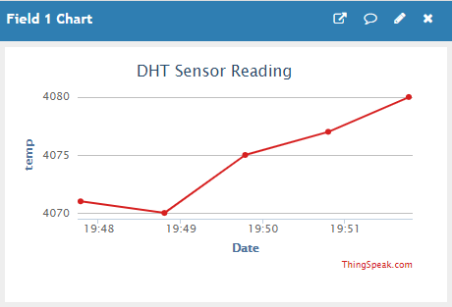

**Question 4**

<https://github.com/Goolog/SIT210-Task3.1P-WebHook.git>

**Question 5**

My system uses a DHT11 Temperature and Relative Humidity sensor. This measures the temperature and humidity of its environment. A practical use of this and webhooks would be to use multiple sensors to monitor the temperatures of all the rooms in your home. Going further, it could be used in a smart home setting with a system that automatically toggles the heating on and off to maintain a particular room temperature.

**References**

[1]"Webhooks | Tutorials", Docs.particle.io, 2021. [Online]. Available: https://docs.particle.io/tutorials/device-cloud/webhooks/. [Accessed: 21- Apr- 2021].